**DAILY ONLINE ACTIVITIES SUMMARY**

|  |  |  |  |  |  |  |  |  |
| --- | --- | --- | --- | --- | --- | --- | --- | --- |
| **Date:** | **27/05/2020** | | | | | **Name:** | **SUJAYA** | |
| **Sem & Sec** | **IV sem & B section** | | | | | **USN:** | **4AL18CS90** | |
| **Online Test Summary** | | | | | | | | |
| **Subject** | | **Object Oriented Concepts** | | | | | | |
| **Max. Marks** | | **30** | | **Score** | | | **25** | |
| **Certification Course Summary** | | | | | | | | |
| **Course** | **Python For Machine Learning** | | | | | | | |
| **Certificate Provider** | | | **Greatlearning academy** | | **Duration** | | | **5.0 hours** |
| **Coding Challenges** | | | | | | | | |
| **Problem Statement1:** Write a C Program to sort an array of integers in ascending order and display the sorted array and Number of passes performed for sorting  **Problem Statement2:** Given an array arr[ ] of the positive integers of size N, the task is to find the largest element on the left side of each index which is smaller than the element present at that index. Note: If no such element is found then print -1. | | | | | | | | |
| **Status: Executed** | | | | | | | | |
| **Uploaded the report in Github** | | | | | **YES** | | | |
| **If yes Repository name** | | | | | **Online-coding** | | | |
| **Uploaded the report in slack** | | | | | **YES** | | | |

**Online Test Summary:** 18CS45(OOC) test was scheduled from 9:15 am t0 9:45am .The portion for the IA was 5th module there were 30 questions and the time assigned was 30 minutes the questions were of mcq type.

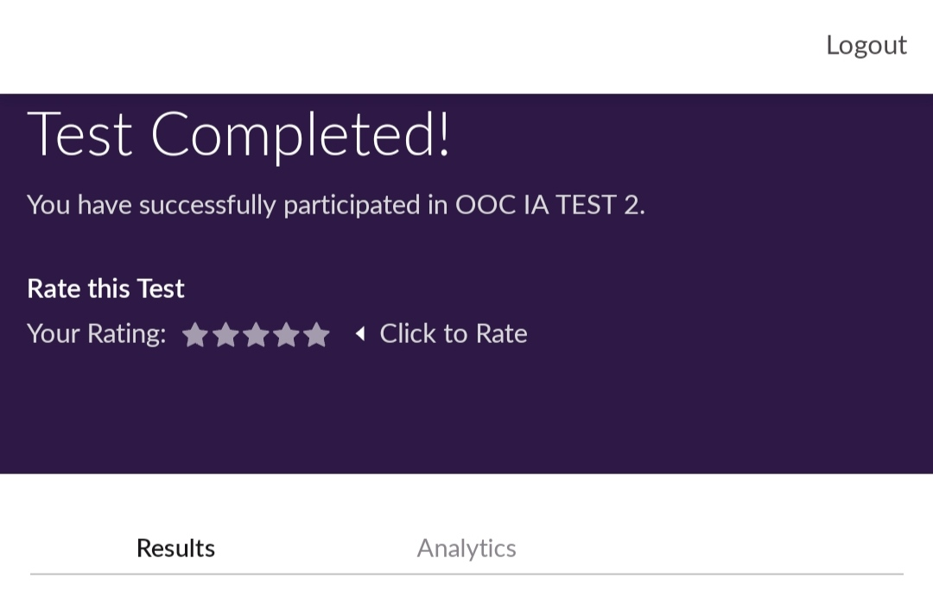

This is the snap shot of completion of the test and marks obtained.

Online Certification Summary: In today’s session I have learnt about Introduction to NumPy and I came to know what exactly it means and I also learnt how to save and load the NumPy arrays and Introduction to Pandas.

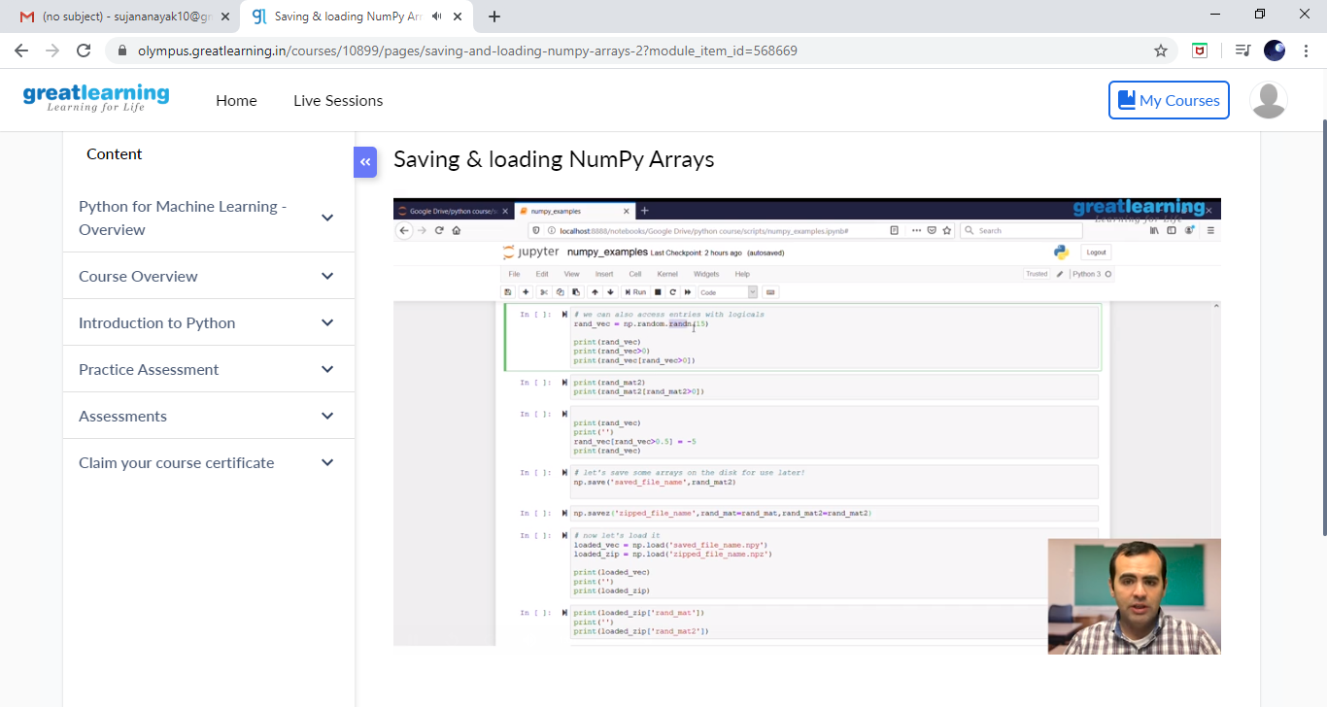

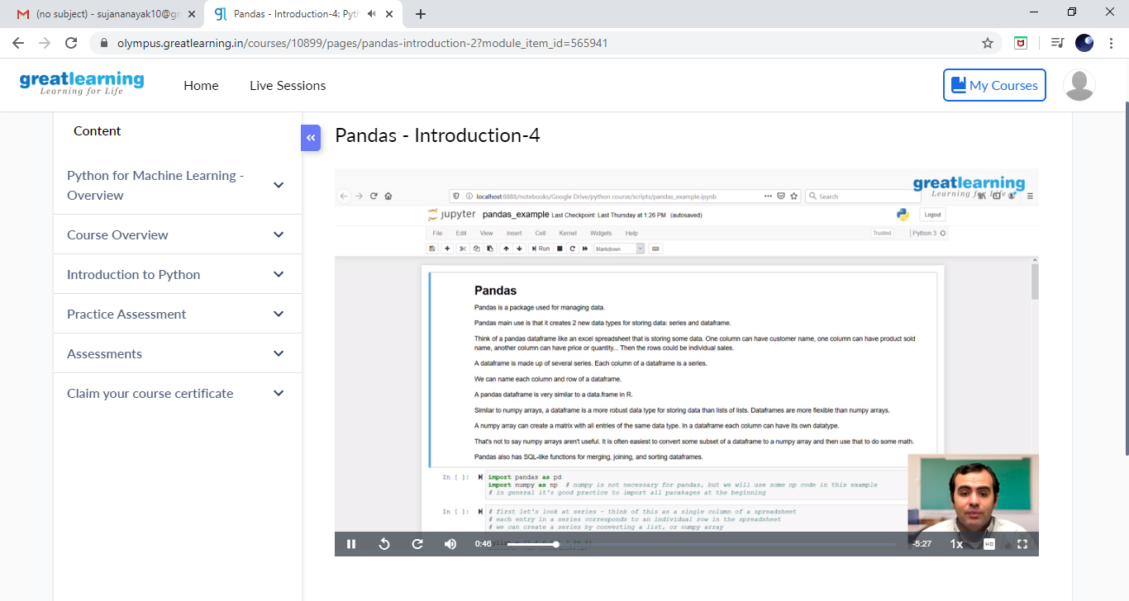

These are the snap shots of today’s sessions.

Online Coding Summary: **Today I had received one program from prof.Vasudev CSE Dept and another from prof.Venkatesh CSE Dept. The programs is mentioned above in the coding challenges(pg.01). I have also uploaded it to my Github repository.**

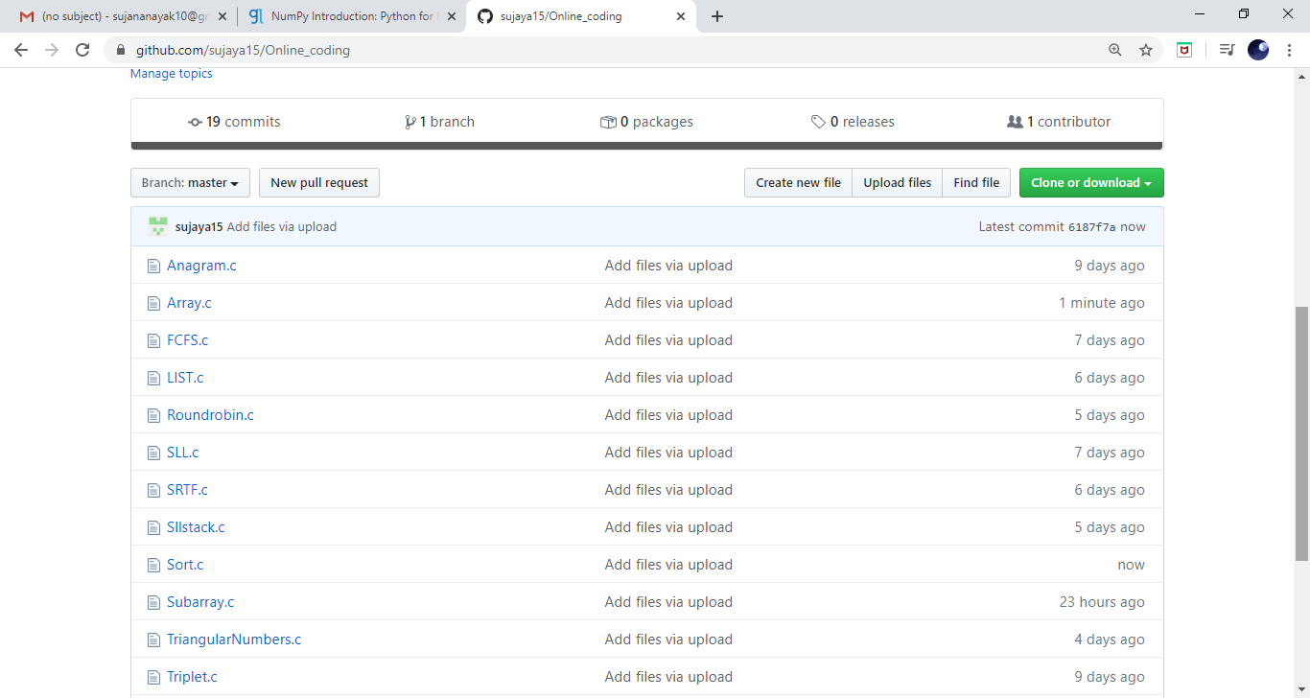

**This is the snap shot of my Github repository** were I have uploaded the code. File name is sort.c and array.c